Files to run: SJF.java, PreemptiveSJF.java, PriorityPreemptive.java

Test SJF

a. 4 processes AT BT

0 7

2 4

4 1

5 4

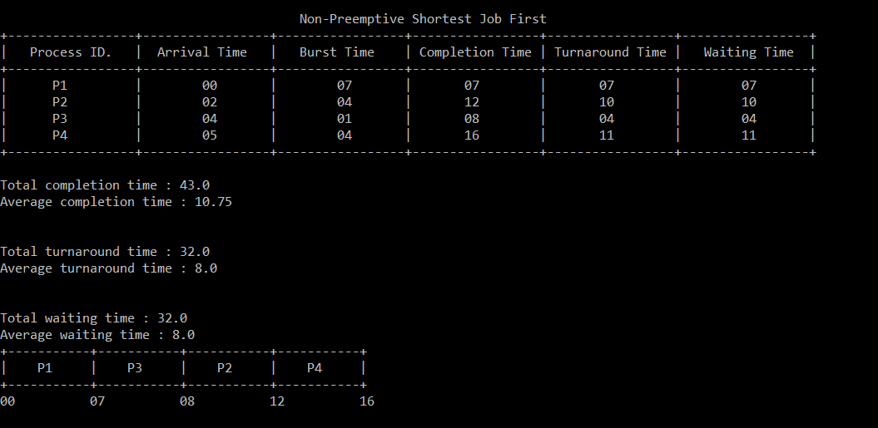

b. 6 processes AT BT

0 6

1 4

5 6

6 6

7 6

8 6

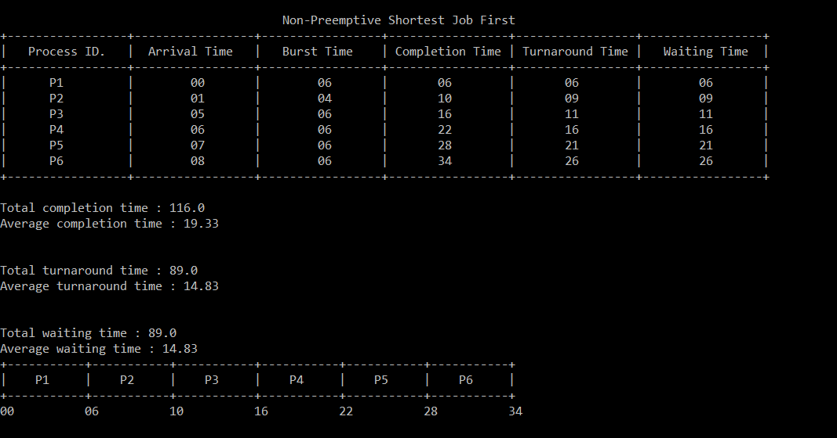

c. 6 processes AT BT

0 8

1 4

2 9

3 5

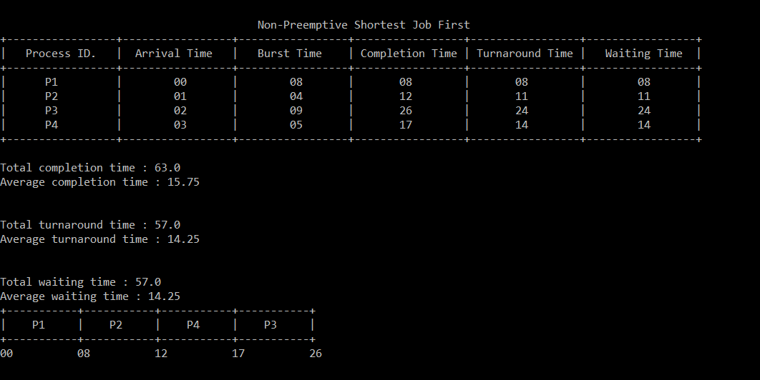

Test Priority Preemptive

1. 6 processes AT BT PRIORITY

0 6 3

1 4 3

5 6 1

6 6 1

7 6 5

1. 6 6

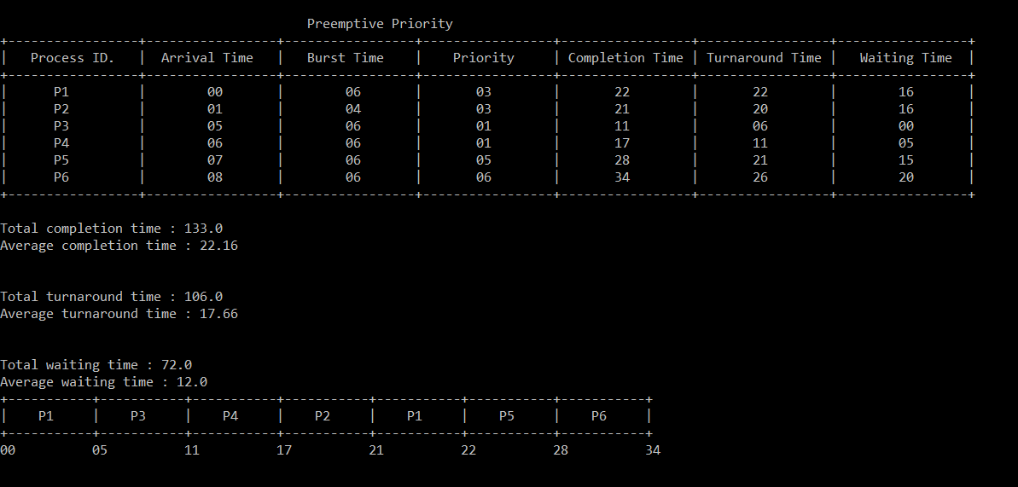

1. 7 processes AT BT PRIORITY

0 1 2

1 7 6

2 3 3

3 6 5

4 5 4

5 15 10

1. 8 9

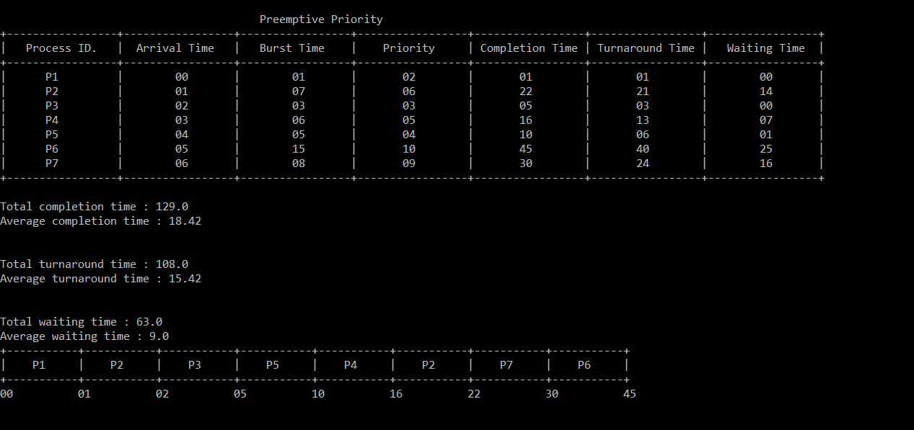

Test Preemptive SJF

1. 6 processes AT BT PRIORITY

0 6 3

1 4 3

5 6 1

6 6 1

1. 6 5

8 6 6

